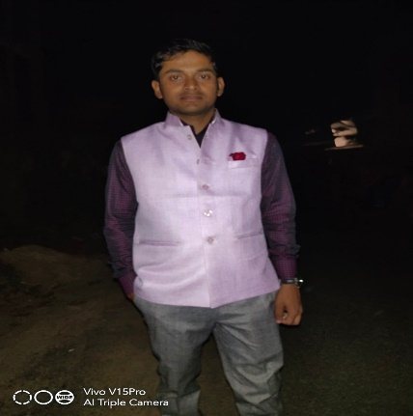

I am a full stack java script web developer. I love to write code.

Learning new things and concept is my passion.

I have completed 15 html and css projects, 3 tailwind projects, 5 bootstrap project and 15 java script projects.

PROFILE

* HTML
* CSS
* TAILWIND CSS
* BOOTSTRAP
* JAVASCRIPT
* REACT JS
* NODE JS
* MONGODB

**SKILLS**

**** [bipulmondal3007@gmail.com](mailto:bipulmondal3007@gmail.com)

**** <https://app.netlify.com/teams/bipulmondal/overview>

**** <https://github.com/BipulMondal>

**** [https://www.linkedin.com/in/bipul-mondal- 883503246/](https://www.linkedin.com/in/bipul-mondal-%20%20883503246/)

** 7003611474**

** Amtala, west Bengal, 743513**

**BIPUL MONDAL**

**FULL STACK JAVASCRIPT WEV DEVELOPER**

**LANGUAGES**

* ENGLISH
* HINDI
* BENGALI

**EDUCATION**

BACHELOR OF COMPUTER APPLICATION

INSTITUTE: INDIRA GANDHI NATIONAL OPEN UNIVERSITY

PROJECTS